Graphing Homework
  AD/AS  ↓,↑, same | Unemployment  (=, <, >)  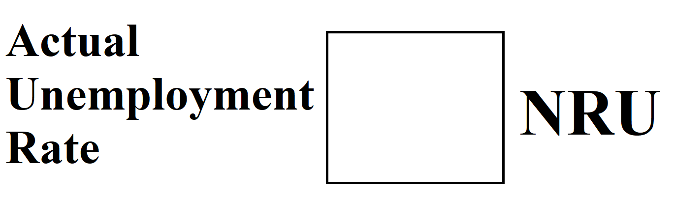 | Phillips Curve (draw the LRPC and SRPC) | Business Cycle
↓,↑, same
↓,↑, same
Potential Output/Long Run Equilibrium
Negative Output Gap
Positive Output Gap

